JOICO Color Excellence Youthlock and Vero K-Pak Color Age Defy Questionnaire

- ……
- ……
- Please explain the technology/ingredients of Youthlock.
Argiplex technology, Gentle Fresh Fragrance technology, Additional Arginine, Buriti Fruit Oil, Collagen
- What is the processing time of Youthlock?
45mins
- Which Youthlock family is this?
NN
- Which Youthlock family is this?
NNA
- Which Youthlock family is this?
NNW
- How many shades do we have in the NNG series of Youthlock?
7
- First time application with Youthlock.
Client is 100% gray and has previously color treated faded lengths and ends on a level 8. Her wish is 8NNG.
How to proceed?
Root area: 8NNG + 20 Volume (6%) Lengths & Ends: 8NNG + 20 Volume (6%) – start timing = 45 minutes
- Regrowth application with Youthlock.
Client is 100% gray; her wish is 8NNG
How to proceed?
Root area: 8NNG + 20 Volume (6%) – start timing 45 min •Lenghts & Ends: emulsify during the last 5 minutes of the processing time
- Which products would you recommend as home maintenance for your clients who have been colored with Youthlock and have the ultimate color longevity?
K-Pak Color Therapy
- When you think of Age Defy you think of.........? Tick the boxes
More than just Gray coverage
Heavier dye load
Pre mixed shades
TCD Technology
Transforms aging hair into youthful hair
3-Defense Technology
- The ideal/potential Age Defy client will say...
My hair is more coarse and wiry as before
My hair is not as shiny anymore
In the past my hair would sit better
My hair is fragile and damaged
I don't like my gray hair
My hair feels dryer than in the past
My color fades faster than before
- True or False?
Reduced melanocyte activity and decreased melanin pigmentation will cause gray hair.
True
- Fill in the missing words of the 3 Defense Technology
Essential Amino Acids, Time released lipids, Bio mimetic ceramides
- True or False?
Trans Cuticle Deliver System:
Low ammonia slightly opens the cuticles
Lysine softens the cuticle scales to allow penetration
Lecithin amino acid actively transports color molecules through and in between the cuticles
False
- True or False?
Vero K-Pak Color Age Defy has a calibrated ammonia %
True
- Which of the shades below are part of Vero K-Pak Color Age Defy?
NPA+, NG+, NGC+, NN+
- True or False?
Vero K-Pak Color Age Defy has a heavier dye-load compared to Vero K-Pak Color
True
- Fill in the missing Age Defy Series on the dots
NN+/NN+/NG+
NG+/NG+/NN+
- Fill in the missing Age Defy Series on the dots
NG+/NN+/
NN+
- Which is the correct Age Defy Formula?
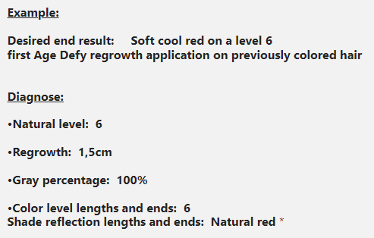
1/2 6NR+ + 1/2 6NN+ and 20Vol 6% roots / 6NR+ and 20Vol L+E)
- Which products would you recommend as home maintenance for your clients who have been colored with Age Defy?
K-Pak or K-Pak Color Therapy when hair is lifted and colored

